Bernard Owusu Sefah

Task 1

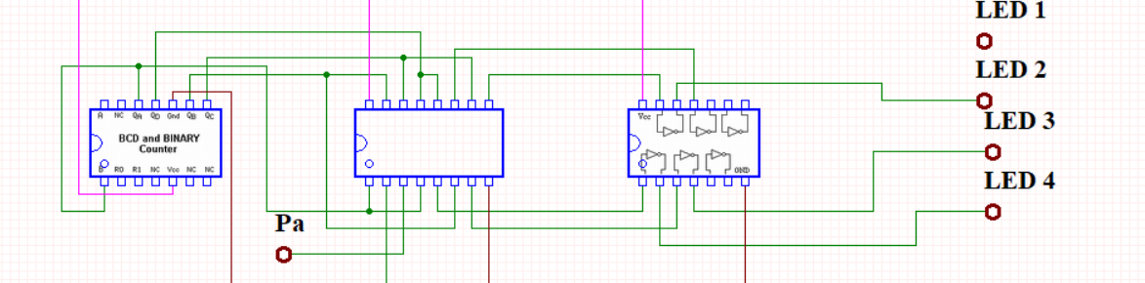Task 2

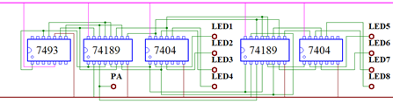

Has the same 16x8 read and write operation as the 32x4 SRAM

Task 3

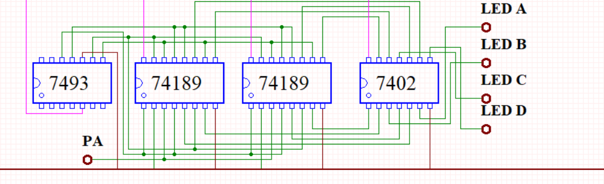

Has the same read and write operation.